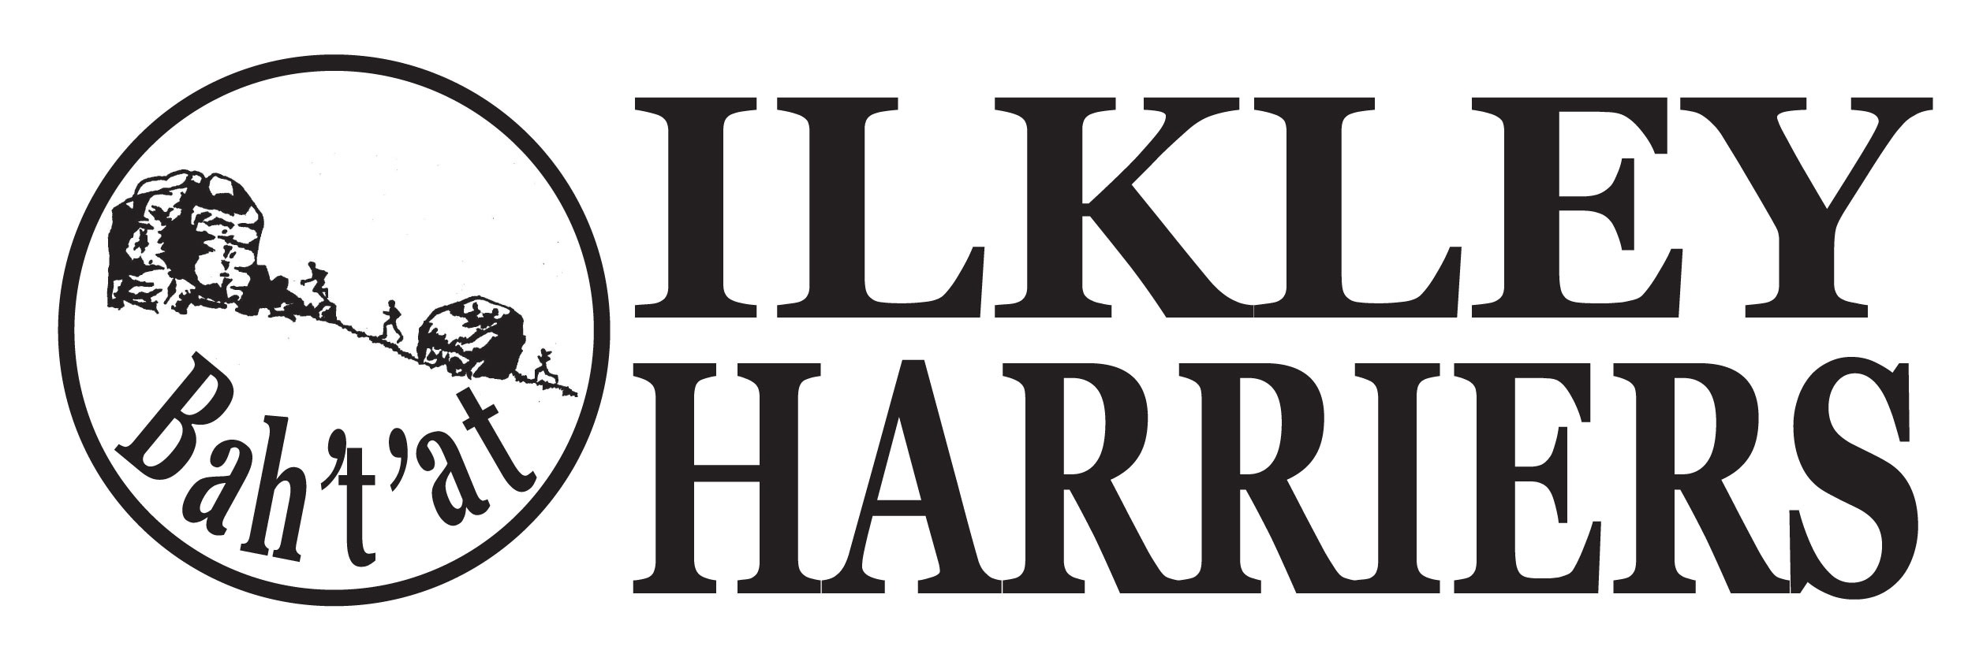
Committee Meeting

Agenda

6th March 2018
- Apologies

2. Minutes of Meeting 6th February 2018

3. Matters arising

4. Running the Club:

4.1 Harrier and Volunteer of the month

4.2 Events: Review of Ilkley Moor Fell race and plans for next year incl discussion of a potential cut-off time and the increase in entrance fee. HDSRL - our race confirmation of 19th June, arrangements re food.

4.3 League races; review of programme and confirmation of choices eg first Bunny run, which 5k in November, replacement for John Carr 1

4.4 Membership update re PaySubsOnline process

4.5 Northern Athletics proposal to proceed with £2 per member charge, despite questioning

4.6 Newsletter progress

4.6 Juniors

5. Developing the Club

5.1 Development plan

5.2 Junior facilities

6. AOB

Next meeting proposed: 8:30pm on Tuesday 3rd April 2018 at ILTSC

Harrier of the month nominations:
5x Michael Lomas for 4th at Rombalds (Ben Sheppard was 3rd), High Cup Nick, 51st at IMFR
4x Euan Brennan - 15.22 5k at Armagh Nationals, 3rd in northern xc, 10th at national xc
5x Jann Smith and Paul Carmen Transgrancarnaria (64k, 10k ft)

Volunteer nominations:
4x Steve Weston for IMFR

